# **Spanish 3 Honors Overview**

At the completion of Spanish 2, I should be able to successfully:

* Introduce myself and others and describe with adjectives
* Talk about foods I enjoy and how to prepare them
* Discuss where I shop and what I buy
* Talk about the past and I can explain when to use the ***preterite*** and when to use the ***imperfect*** tense
* Go the doctor and describe my illness
* Discuss travel and leisure activities
* Use the verbs ***ser*** and ***estar*** correctly
* Use the verbs ***saber*** and ***conocer*** correctly

**Use this packet to help you get a head start in Spanish 3 honors this year! It is optional, but it is highly recommended to help you feel prepared. This will give you an idea of what you can expect in the course.**

**What to expect in 3 Honors:**

* **Homework**
  + Typically 15-30 minutes each night
  + Examples**:**
    - Vocab or grammar worksheet
    - Workbook page
    - Review new vocabulary
  + See example activities below
* **Vocabulary**
  + Vocabulary is introduced at the beginning of the unit and then used throughout
    - Rather than broken into Desafíos
  + See Spanish 3 Honors Unit 1 list below
    - Quizlet link is included
* **Grammar**
  + The grammar in 3H is more detailed than in Academic
  + **Topics to review:**
    - ***\*The following links will take you to a practice quiz for each grammar topic. There is an explanation on each topic on the side in case you need to review first!***
    - Present tense
      * Regulars <https://studyspanish.com/grammar/test/regverb3>
      * Ser v. Estar <https://studyspanish.com/grammar/test/serest2>
      * Stem-changers (o to ue) <https://studyspanish.com/grammar/test/stemue>
      * Stem-changers (e to ie) <https://studyspanish.com/grammar/test/stemie>
      * Stem-changers (e to i) ( <https://studyspanish.com/grammar/test/stemi>
      * Tener and Venir <https://studyspanish.com/grammar/test/tenven>
      * Estar, Ir, Dar <https://studyspanish.com/grammar/test/estarirdar>
      * Gustar <https://studyspanish.com/grammar/test/gustar>
    - Present progressive (-ing)
      * <https://studyspanish.com/grammar/test/presprog>
    - Preterite

<https://studyspanish.com/grammar/test/pret1>

* + - Commands (positive and negative tú form)
      * Regulars <https://studyspanish.com/grammar/test/informcomm1>
      * Irregulars <https://studyspanish.com/grammar/test/irregtucomm>
    - Imperfect
      * <https://studyspanish.com/grammar/test/imp1>
      * <https://studyspanish.com/grammar/test/imp2>
    - Question words
      * <https://studyspanish.com/grammar/test/quest>

**SP3H Unit 1 Culture Reading:**

This is the culture reading you will see in Unit 1. We will be learning about Uruguay and Argentina. Try reading the article and answering the questions below. These are typical of cultural readings in the course.

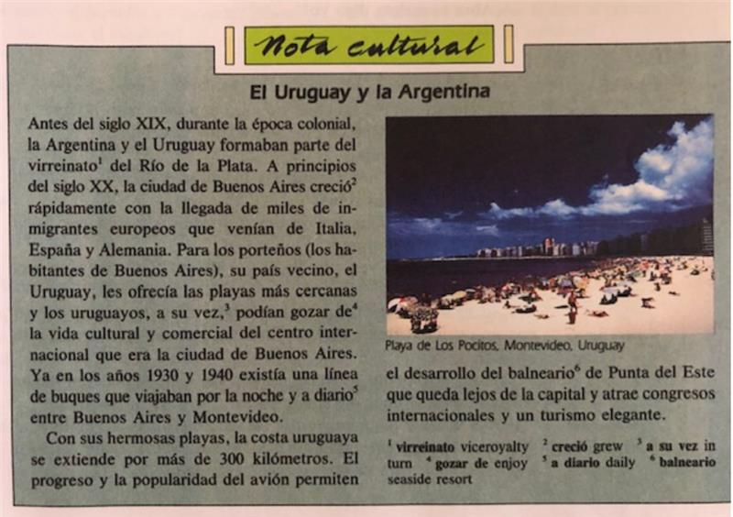

1. ¿Qué significa “porteño” en inglés?
2. ¿Cuál es el grupo más grande de inmigrantes en Argentina?
3. ¿En qué país está Montevideo?
4. ¿Qué es la atracción para millones de turistas cada año?

**SP3H Unit 1 Vocab List:**

Quizlet Link: <https://quizlet.com/_3ngr9i?x=1jqt&i=18rmvy>

***La descripción física***

el pelo/el cabello ________________________________

moreno ________________________________

negro ________________________________

rubio ________________________________

pelirrojo ________________________________

castaño ________________________________

rojizo ________________________________

ondulado ________________________________

rizado ________________________________

corto ________________________________

liso ________________________________

largo ________________________________

los flequillos de pelo ________________________________

los ojos ________________________________

negros ________________________________

de color café ________________________________

verdes ________________________________

azules ________________________________

de color avellana ________________________________

la cara ________________________________

ovalada ________________________________

redonda ________________________________

rectangular ________________________________

cuadrada ________________________________

la talla ________________________________

alto ________________________________

bajo ________________________________

de talla mediana ________________________________

la apariencia general ________________________________

delgado/esbelto ________________________________

grueso ________________________________

gordo ________________________________

atlético ________________________________

fuerte ________________________________

débil ________________________________

flaco ________________________________

las señas particulares ________________________________

anteojos/gafas/lentes ________________________________

lentes de contacto ________________________________

calvo ________________________________

una cicatriz ________________________________

la barbilla ________________________________

bigotes ________________________________

una cola de caballo ________________________________

un lunar ________________________________

la mejilla ________________________________

las pecas ________________________________

***La identidad***

el nombre ________________________________

el apellido ________________________________

la nacionalidad ________________________________

el país de origen ________________________________

la fecha ________________________________

el lugar de nacimiento ________________________________

nació ________________________________

nací ________________________________

la edad ________________________________

el domicilio ________________________________

la dirección ________________________________

la profesión ________________________________

el estado civil ________________________________

casada ________________________________

soltera ________________________________

los documentos de identidad ________________________________

el pasaporte ________________________________

la tarjeta de identidad ________________________________

el carnet de conducir ________________________________

el carnet estudiantil ________________________________

***Para conversar: las presentaciones***

Te presento... ________________________________

Me gustaría presentarle... ________________________________

¡Qué tal! ________________________________

Encantado. ________________________________

Un placer. ________________________________

Encantada de conocerlo. ________________________________

Mucho gusto en conocerlo. ________________________________

El gusto es mío. ________________________________

***Los países y las nacionalidades***

Países hispanos nacionalidad

la Argentina ________________________________

Bolivia ________________________________

Colombia ________________________________

Costa rica ________________________________

Cuba ________________________________

Chile ________________________________

el Ecuador ________________________________

El Salvador ________________________________

España ________________________________

Guatemala ________________________________

Honduras ________________________________

México ________________________________

Nicaragua ________________________________

el Panamá ________________________________

Paraguay ________________________________

el Perú ________________________________

Puerto Rico ________________________________

la Republica Dominicana ________________________________

Uruguay ________________________________

Venezuela ________________________________

Otros países del mundo nacionalidad

Alemania ________________________________

el Brasil ________________________________

el Canadá ________________________________

China ________________________________

los Estados Unidos ________________________________

las Filipinas ________________________________

Grecia ________________________________

Holanda ________________________________

India ________________________________

Irlanda ________________________________

Israel ________________________________

el Japón ________________________________

Noruega ________________________________

Polonia ________________________________

Portugal ________________________________

Rusia ________________________________

Suecia ________________________________

Vietnam ________________________________

**Homework Example:**

